***Milestone 3 : Updated SQL Queries***



|  |  |
| --- | --- |
| *Submitted By* | *Registration No.* |
| *Maira Zafar* | *22PWCSE2106* |
| *Saira Zafar* | *22PWCSE2128* |
|  |  |

**Subject:** *Database Management System Lab*

**Submitted To:** *Engr. Summayyea Salahuddin*

**Project Title:** *Smart Food Delivery Box Online Mart*

**Department of Computer Systems Engineering**

**CRM: SQL Databases and queries**

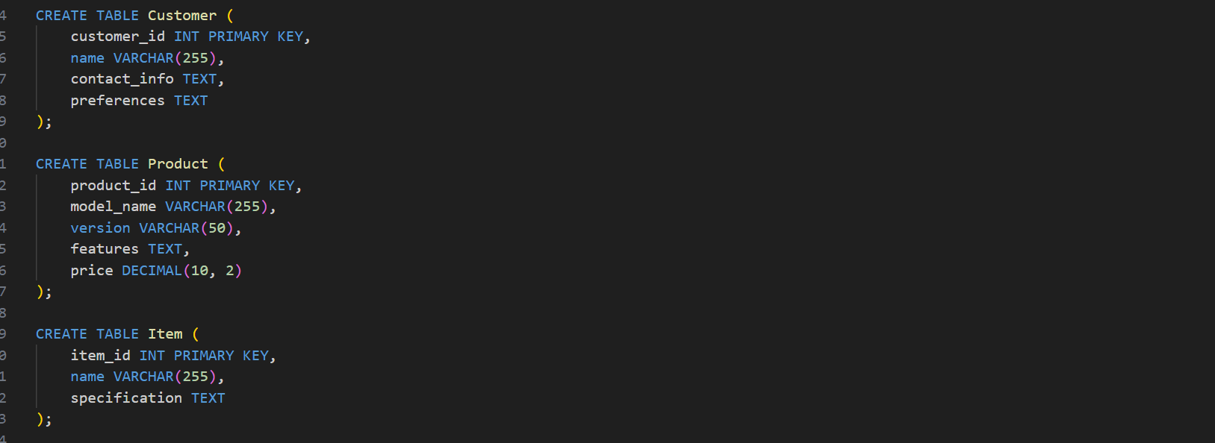

**Database Of Product , Customer:**

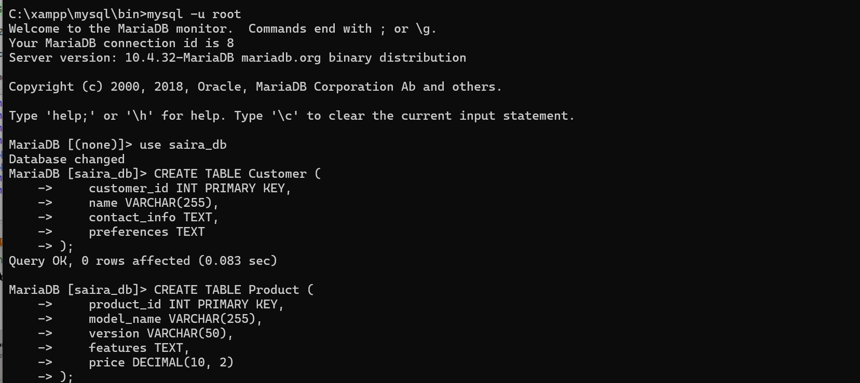

**Database Of Item , Product _Item , Supplier_Item**

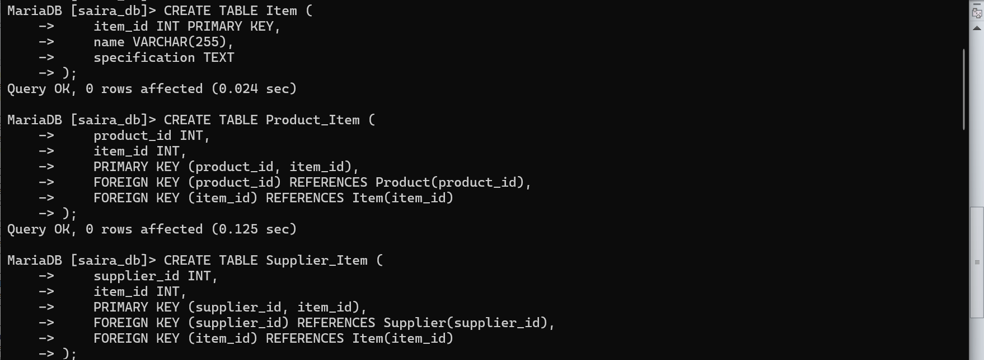

**Database Of Shipment ,Shipment_Item ,Order**

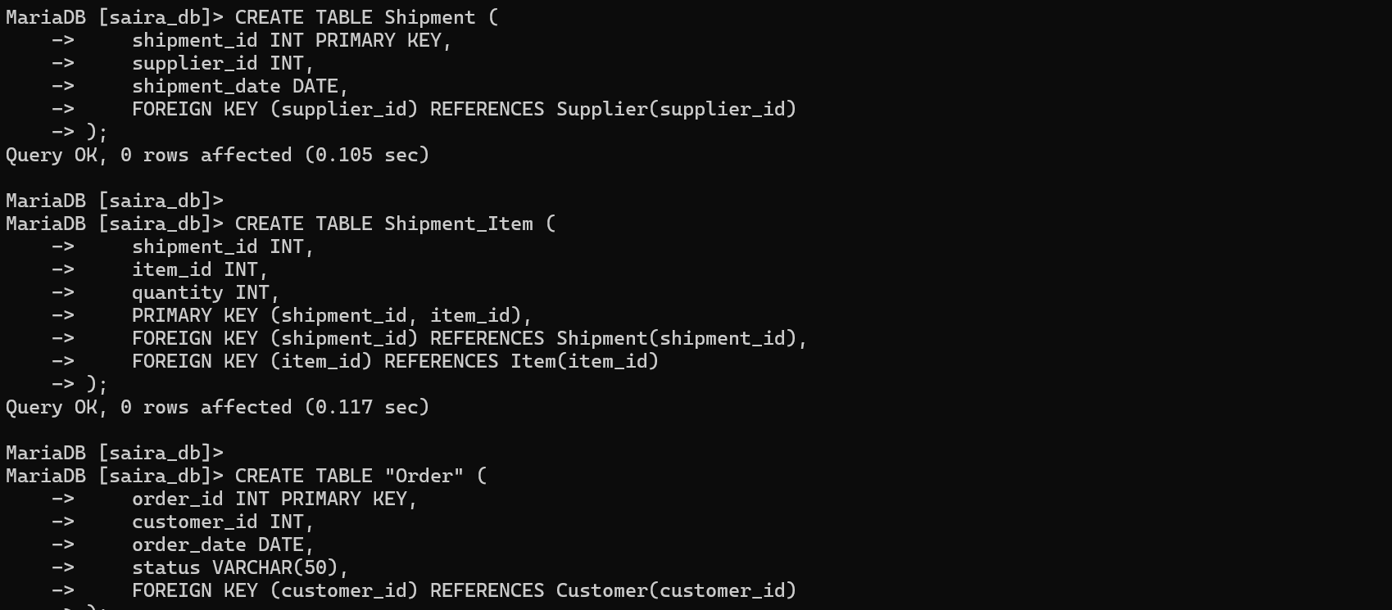

**Total Tables In Databases:**

